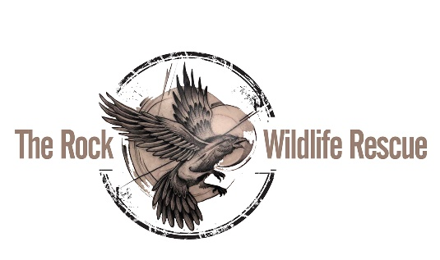

Pre-Authorized Debit (PAD) Agreement

Thank-you for your interest in The Rock Wildlife Rescue! Please use this form to authorize monthly donations from you bank account.

The Debit will be Processed on the 15th day of each month or on the next business day
Please debit my bank account: $ __________

Please send a charitable tax receipt (will be issued at the end of the year): Y or N (circle one)

Name:___________________________________
Address:_____________________________________________________________________
Phone: ________________________ Email: _______________________________________

This donation is made on behalf of (please check one): an Individual a Business

I may revoke my authorization at any time, subject to providing notice of 30 days. To obtain a sample cancellation form, or for more information on my right to cancel a PAD Agreement, I may contact my financial institution or visit www.cdnpay.ca.

I have certain recourse rights if any debit does not comply with this agreement. For example, I have the right to receive reimbursement for any debit that is not authorized or is not consistent with this PAD Agreement. To obtain more information on my recourse rights, I may contact my financial institution.

Signed: _________________________ Date:_____________________

Please send this completed form and a VOID cheque to:

The Rock Wildlife Rescue
110 Quigley’s Lane
Torbay NL A1K 1A5

Tel: 709-727-0557
Email: therockwildliferescue@gmail.com

THANK-YOU FOR YOUR SUPPORT!!

